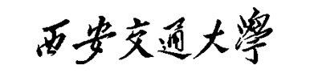

课 程 实 验 报 告

实验名称： 二次规划问题编程证明

姓名: 林圣翔
学号: 2223312202
专业班级: 计试2201
指导教师: 罗敏楠教授
报告日期: 2025.10.13



一、实验目的
1.研究条件数对梯度下降法收敛性能的影响。
2.提升科学计算和结果可视化的实践能力。

二、实验内容
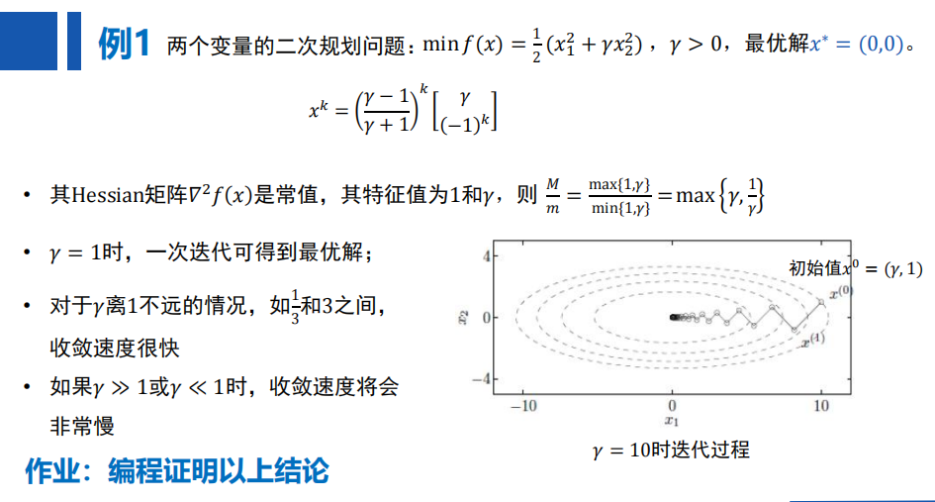

实验环境
1.系统环境：基于Ubuntu 20.04.6 LTS版本
2.编程语言：Python 3.10

四、实验过程
- 环境配置
1.1.创建 Conda 虚拟环境
conda create -n YHFFJC python=3.10
1.2.激活 Conda 虚拟环境
conda activate YHFFJC
1.3.安装项目依赖包
pip install -r requirements.txt
- 代码实现
  - 具体函数及其功能如下表所示
函数名 | 功能描述
analytical_solution(k, y) | 计算梯度下降法在二次优化问题中的解析解，基于系数项(y-1)/(y+1)^k分别计算x1和x2分量
objective_function(x1, x2, y) | 计算二次目标函数值，用于评估当前解的优劣
iterations_to_convergence(y_values, tolerance_values, max_iterations) | 分析不同条件数和容忍度下梯度下降的收敛性能，通过迭代计算解析解直至目标函数值低于容忍度阈值
plot_iterations_to_convergence(y_values, tolerance_values) | 可视化收敛性能分析结果，使用半对数坐标展示不同容忍度下迭代次数随条件数的变化趋势
plot_3d_surface_and_trajectory() | 生成3D曲面和等高线图展示目标函数 landscape及梯度下降轨迹，直观呈现优化过程
plot_initial_iterations() | 绘制前几次迭代中目标函数值的变化曲线，展示不同条件数对收敛速度的影响
  - 主函数执行流程
    - 调用plot_initial_iterations()函数
取γ=[0.1,0.5,1,2,3,5]，设置最大迭代次数为10，绘制前10次迭代过程中目标函数值的变化曲线，展示不同条件数对梯度下降收敛速度的影响。
    - 调用plot_3d_surface_and_trajectory()函数
选取γ=[0.01,0.1,0.33,1,3,10,100]代表性条件数，分别生成目标函数的3D曲面图和等高线图，并在图中绘制梯度下降的迭代轨迹，直观呈现优化算法在不同地形条件下的搜索路径。
    - 调用plot_iterations_to_convergence(y_values,tolerance_values)函数
使用γ=[0.001,0.01,0.1,0.33,1,3,10,100,10000,100000]和容忍度tolerance_values=[1e-4,1e-5,1e-6,1e-7,1e-8]，系统分析不同精度要求下梯度下降达到收敛所需的迭代次数，绘制收敛性能曲线并保存数值结果到CSV文件。
- 运行代码
执行如下命令，程序依次完成步骤2.2.1-2.2.3。
python run.py

五、实验结果
1.不同条件数下的初期迭代情况
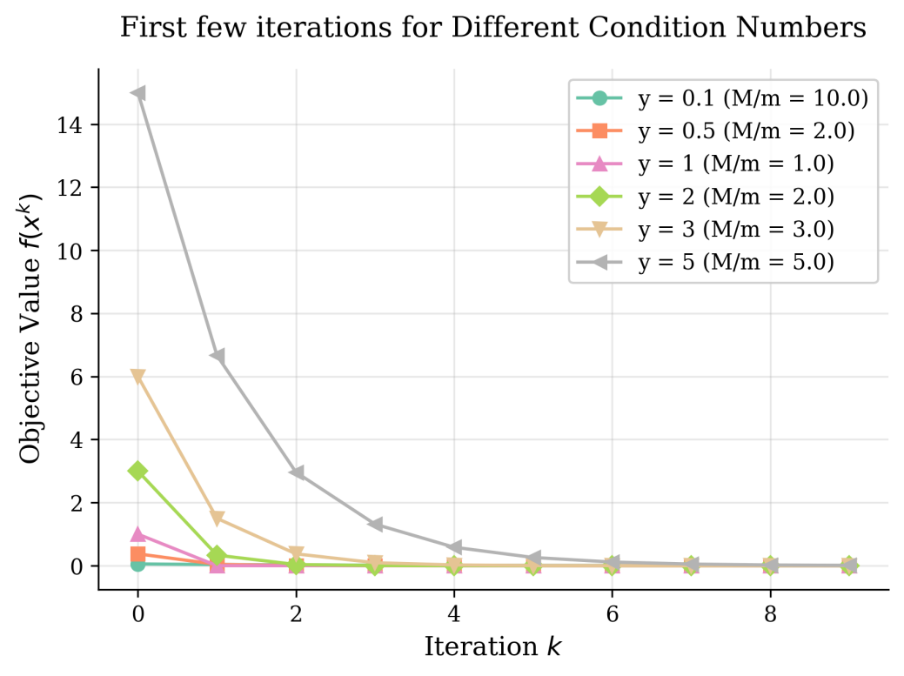
2.三维曲面与二维等高线轨迹随γ值的变化
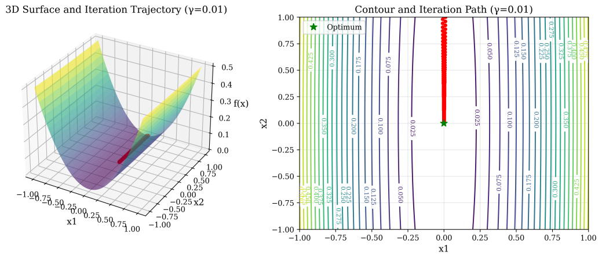
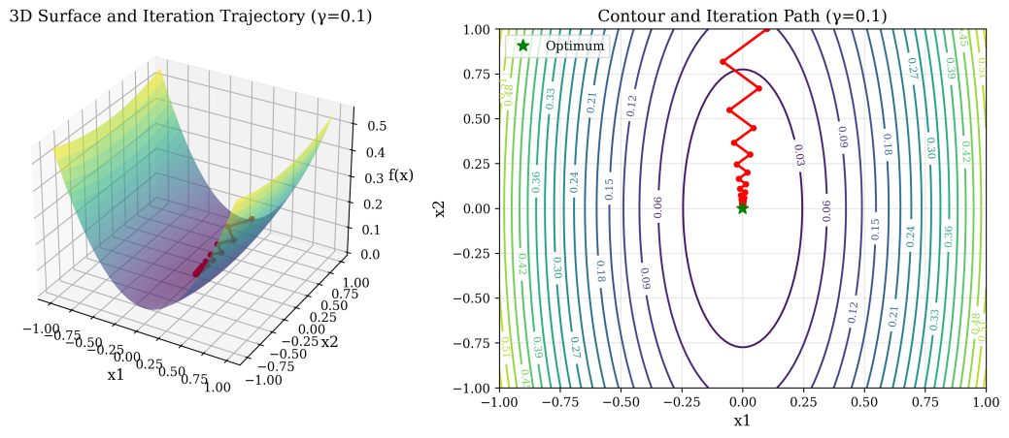
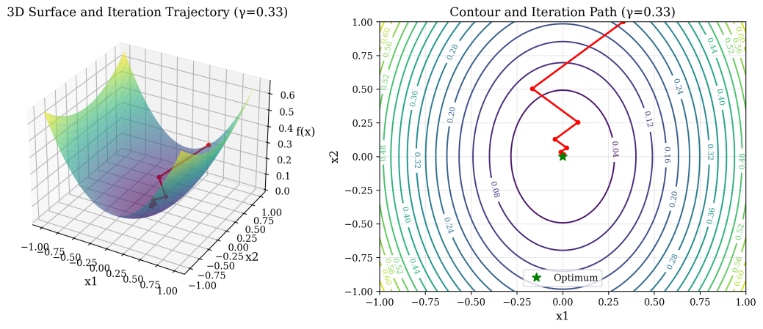
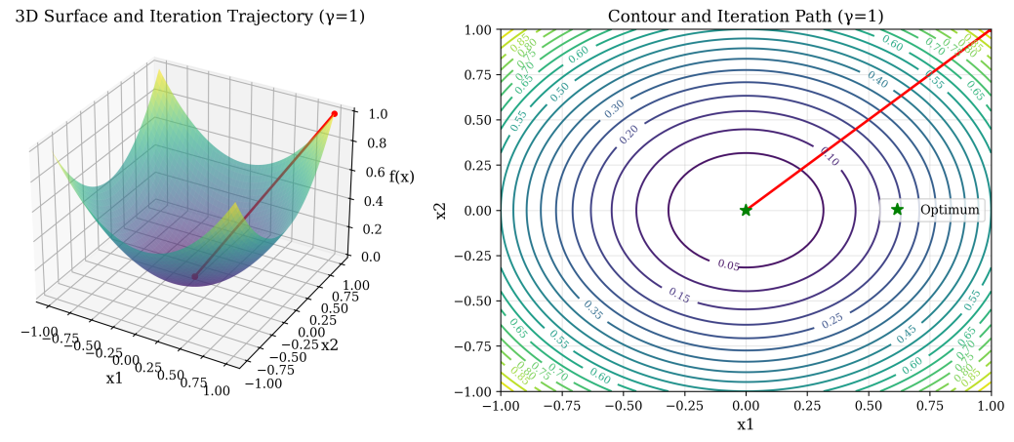
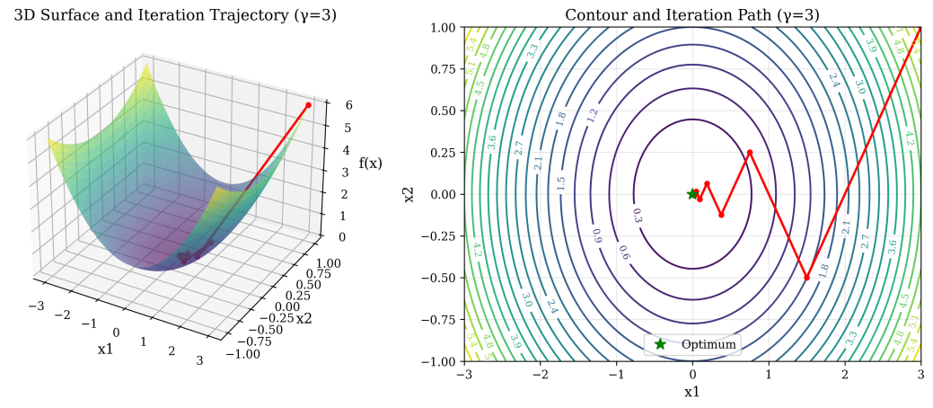
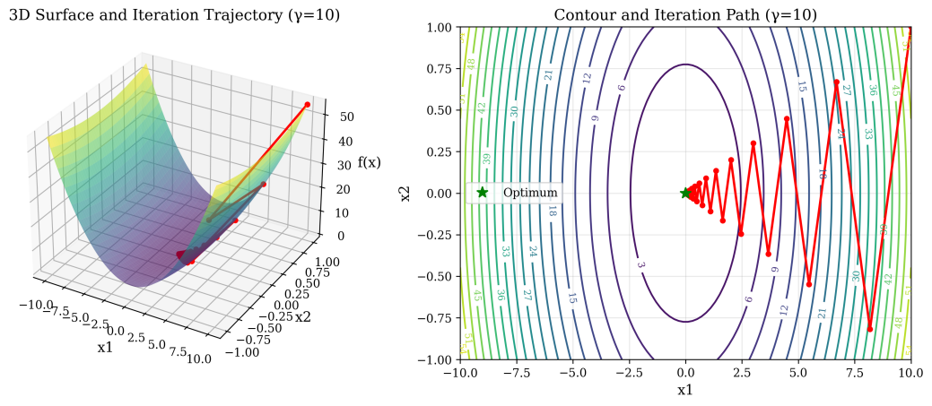
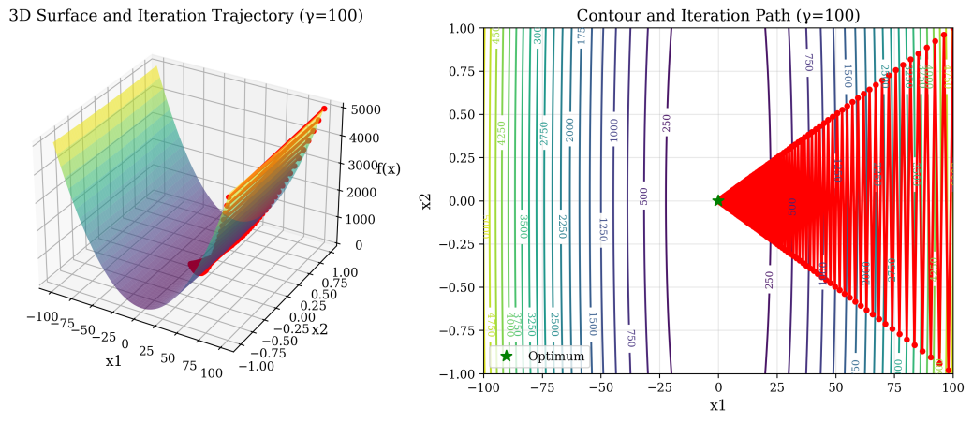
3.不同γ值与容差下的收敛迭代参数
γ | tolerance_values |  |  |  |  | M/m | Convergence Rate
 | 1e-4 | 1e-5 | 1e-6 | 1e-7 | 1e-8
0.001 | 403 | 979 | 1554 | 2130 | 2706 | 1000 | 0.998001998
0.01 | 99 | 156 | 214 | 271 | 329 | 100 | 0.98019802
0.1 | 16 | 22 | 28 | 33 | 39 | 10 | 0.818181818
0.33 | 6 | 8 | 9 | 11 | 13 | 3.0303 | 0.503759398
1 | 1 | 1 | 1 | 1 | 1 | 1 | 0
3 | 8 | 10 | 12 | 13 | 15 | 3 | 0.5
10 | 33 | 39 | 45 | 51 | 56 | 10 | 0.818181818
100 | 444 | 501 | 559 | 617 | 674 | 100 | 0.98019802
10000 | 67345 | 73102 | 78858 | 84615 | 90371 | 10000 | 0.99980002
100000 | 788577 | 846141 | 903706 | 961271 | 1018835 | 100000 | 0.99998
不同γ值与容差下的收敛迭代次数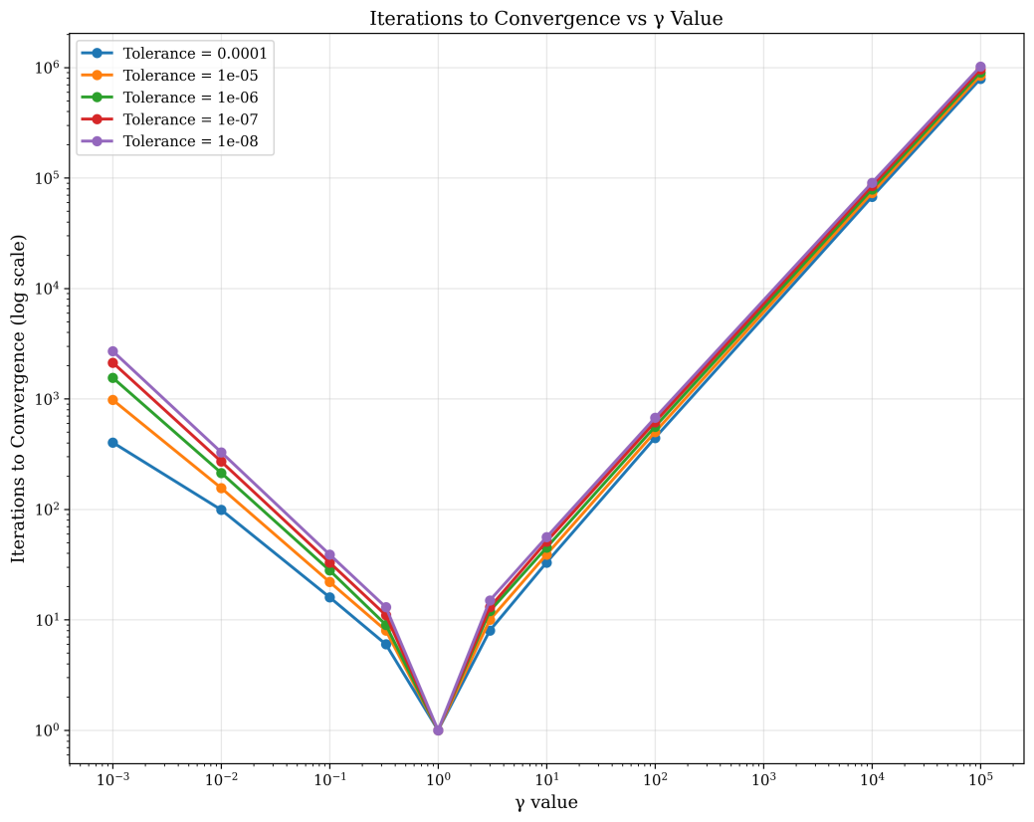

实验结论
- γ=1时，一次迭代可得到最优解。
- 对于γ离1不远的情况，如1/3和3之间，收敛速度很快。
- 如果γ≫1或γ≪1时，收敛速度将会非常慢。

附录：
requirements.txt
scipy
pandas
matplotlib
run.py
import numpy as np
import matplotlib.pyplot as plt
import os
import pandas as pd

if not os.path.exists('result'):
os.makedirs('result')

y_values_extended = [0.001, 0.01, 0.1, 0.33, 1, 3, 10, 100, 10000, 100000]

def analytical_solution(k, y):
"""Analytical solution: x^k = ((y-1)/(y+1))^k * [y, (-1)^k]"""
coefficient = ((y - 1) / (y + 1)) ** k
x1 = coefficient * y
x2 = coefficient * ((-1) ** k)
return np.array([x1, x2])

def objective_function(x1, x2, y):
"""Objective function: f(x) = 1/2(x1^2 + y*x2^2)"""
return 0.5 * (x1**2 + y * x2**2)

def iterations_to_convergence(y_values, tolerance_values, max_iterations=10000000000):
results = {}
for y in y_values:
results[y] = {}
for tolerance in tolerance_values:
iterations = 0
converged = False
for k in range(max_iterations):
x_k = analytical_solution(k, y)
f_val = objective_function(x_k[0], x_k[1], y)
if f_val < tolerance:
iterations = k
converged = True
break
if not converged:
iterations = max_iterations
results[y][tolerance] = iterations
df = pd.DataFrame(results).T
df.columns = [f'tol={tol}' for tol in tolerance_values]
df['M/m'] = [max(y, 1/y) for y in y_values]
df['Convergence Rate'] = [abs((y-1)/(y+1)) for y in y_values]
return df

def plot_iterations_to_convergence(y_values, tolerance_values):
df = iterations_to_convergence(y_values, tolerance_values)
plt.figure(figsize=(10, 8))
for i, tolerance in enumerate(tolerance_values):
col_name = f'tol={tolerance}'
plt.semilogy(y_values, df[col_name], 'o-', linewidth=2, label=f'Tolerance = {tolerance}')
plt.xlabel('γ value')
plt.ylabel('Iterations to Convergence (log scale)')
plt.title('Iterations to Convergence vs γ Value')
plt.legend()
plt.grid(True, alpha=0.3)
plt.xscale('log')
plt.tight_layout()
plt.savefig('result/iterations_vs_γ.png', dpi=300, bbox_inches='tight')
plt.show()
return df

def plot_3d_surface_and_trajectory():
y_cases = [0.01, 0.1, 0.33, 1, 3, 10, 100]
for y in y_cases:
x1_range = max(1, y)
x1 = np.linspace(-x1_range, x1_range, 100)
x2 = np.linspace(-1, 1, 100)
X1, X2 = np.meshgrid(x1, x2)
Z = objective_function(X1, X2, y)
max_iterations = 10000
trajectory_x1 = []
trajectory_x2 = []
trajectory_z = []
for k in range(max_iterations):
x_k = analytical_solution(k, y)
z_val = objective_function(x_k[0], x_k[1], y)
trajectory_x1.append(x_k[0])
trajectory_x2.append(x_k[1])
trajectory_z.append(z_val)
fig = plt.figure(figsize=(12, 5))
ax1 = fig.add_subplot(121, projection='3d')
ax1.plot_surface(X1, X2, Z, cmap='viridis', alpha=0.6)
ax1.plot(trajectory_x1, trajectory_x2, trajectory_z, 'ro-', linewidth=2, markersize=4)
ax1.set_xlabel('x1')
ax1.set_ylabel('x2')
ax1.set_zlabel('f(x)')
ax1.set_title(f'3D Surface and Iteration Trajectory (γ={y})')
ax2 = fig.add_subplot(122)
contour = ax2.contour(X1, X2, Z, levels=20)
ax2.clabel(contour, inline=True, fontsize=8)
ax2.plot(trajectory_x1, trajectory_x2, 'ro-', linewidth=2, markersize=4)
ax2.plot(0, 0, 'g*', markersize=10, label='Optimum')
ax2.set_xlabel('x1')
ax2.set_ylabel('x2')
ax2.set_title(f'Contour and Iteration Path (γ={y})')
ax2.legend()
ax2.grid(True, alpha=0.3)
plt.tight_layout()
plt.savefig(f'result/3d_surface_trajectory_γ={y}.png', dpi=300, bbox_inches='tight')
plt.show()

def plot_initial_iterations():
"""Plot first few iterations for different y values with publication quality"""
# Set publication quality style
plt.rcParams.update({
'font.family': 'serif',
'font.size': 11,
'axes.labelsize': 12,
'axes.titlesize': 13,
'legend.fontsize': 10,
'xtick.labelsize': 10,
'ytick.labelsize': 10,
'lines.linewidth': 1.5,
'lines.markersize': 6,
})
y_values = [0.1, 0.5, 1, 2, 3, 5]
colors = plt.cm.Set2(np.linspace(0, 1, len(y_values)))
markers = ['o', 's', '^', 'D', 'v', '<']
max_iterations = 10
fig, ax = plt.subplots(figsize=(6, 4.5))
for i, y in enumerate(y_values):
f_values = []
for k in range(max_iterations):
x_k = analytical_solution(k, y)
f_val = objective_function(x_k[0], x_k[1], y)
f_values.append(f_val)
ax.plot(range(max_iterations), f_values,
color=colors[i],
marker=markers[i],
linewidth=1.5,
label=f'y = {y} (M/m = {max(y, 1/y):.1f})')
ax.set_xlabel('Iteration $k$')
ax.set_ylabel('Objective Value $f(x^k)$')
ax.set_title('First few iterations for Different Condition Numbers', pad=15)
ax.legend(loc='upper right', frameon=True, framealpha=0.9)
ax.grid(True, alpha=0.3)
ax.set_xlim(-0.5, max_iterations - 0.5)
ax.spines['top'].set_visible(False)
ax.spines['right'].set_visible(False)
plt.tight_layout()
plt.savefig('result/initial_iterations.png', bbox_inches='tight', dpi=300)
plt.show()

print("Generating visualizations...")
print("First few iterations")
plot_initial_iterations()
print("3D surface and trajectory")
plot_3d_surface_and_trajectory()
print("Iterations to convergence analysis")
tolerance_values = [0.0001, 0.00001, 0.000001, 0.0000001, 0.00000001]
df = plot_iterations_to_convergence(y_values_extended, tolerance_values)
print("\nIterations to convergence for different γ values and tolerances:")
print(df)
df.to_csv('result/iterations_to_convergence_table.csv')
print("\nIterations table saved to 'result/iterations_to_convergence_table.csv'")

